Nifi Configuration issues and Solutions

By Joseph DeArce 06/03/18

Nifi Configuration issues and Solutions

What is Apache Nifi
NiFi was built to automate the flow of data between systems. While the term 'dataflow' is used in a variety of contexts, we use it here to mean the automated and managed flow of information between systems. This problem space has been around ever since enterprises had more than one system, where some of the systems created data and some of the systems consumed data. The problems and solution patterns that emerged have been discussed and articulated extensively. A comprehensive and readily consumed form is found in the Enterprise Integration Patterns.

Some of the high-level challenges of dataflow include:
- Systems fail
- Networks fail, disks fail, software crashes, people make mistakes.
- Data access exceeds capacity to consume

Sometimes a given data source can outpace some part of the processing or delivery chain - it only takes one weak-link to have an issue.

Boundary conditions are mere suggestions
You will invariably get data that is too big, too small, too fast, too slow, corrupt, wrong, or in the wrong format.

What is noise one day becomes signal the next
Priorities of an organization change - rapidly. Enabling new flows and changing existing ones must be fast.

Systems evolve at different rates
The protocols and formats used by a given system can change anytime and often irrespective of the systems around them. Dataflow exists to connect what is essentially a massively distributed system of components that are loosely or not-at-all designed to work together.

Compliance and security
Laws, regulations, and policies change. Business to business agreements change. System to system and system to user interactions must be secure, trusted, accountable.

Continuous improvement occurs in production
It is often not possible to come even close to replicating production environments in the lab.
Over the years dataflow has been one of those necessary evils in an architecture. Now though there are a number of active and rapidly evolving movements making dataflow a lot more interesting and a lot more vital to the success of a given enterprise.

Nifi Configuration issues and Solutions

Download Java from Oracle
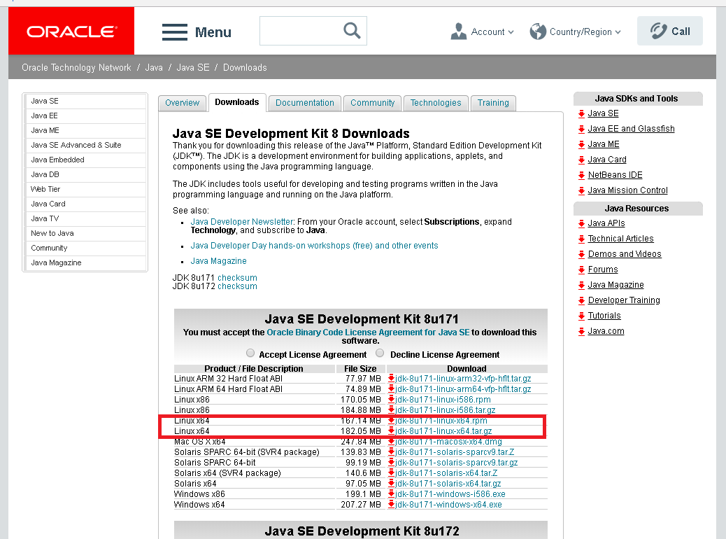

The first step is to download Java from the Oracle web site ‘http://www.oracle.com/technetwork/java/javase/downloads/jdk8-downloads-2133151.html’ the production version is ‘jdk-8u171-linux-x64.tar.gz’ it is in the form of a zip archive.

Decompress the archive to your home directory or a staging directory. This directory will now be your JAVA_HOME and an environmental variable will have to be created. You may be asking why we should be doing this the answer to this is simple you use the default JAVA_HOME it will not work why this I do not know.

Special Note for Java users
Oracle’s current Java version is 10 but this version is not the production version that will be coming out at the end of the year as support for Java 8 will end on 1/2019 and then 11 LTS will be the version that everyone will be migrating to, so that’s my reason.

Support URL: http://www.oracle.com/technetwork/java/javase/eol-135779.html

export JAVA_HOME=/home/jdearce/jdk1.8.0_171

Nifi Configuration issues and Solutions

Download Nifi from Apache
- The first step is to download Apache Nifi from the Apache web site ‘https://nifi.apache.org/download.html’ the current version is 1.6.0 it is in the form of a TGZ file or a zip archive.
- Decompress the archive to your home directory or a staging directory. This directory will now have to be copied the /opt directory which is for optional software, so that it will not interfere with anything else.
- Using the file manager on you OS move the ‘nifi-1.6.0’ directory to the /opt directory using a cut operation to move the hole directory.

Now we will need a terminal to issue Linux commands. Now use the cd /opt command to move to the /opt directory and another cd to move to the nifi-1.6.0 directory and then to bin.

Here we will issue an ls -Al to see if you have execute privilege on the nifi.sh. I do, so we just need to issue the command below. Then navigate to the bin directory here we will issue a number of commands.

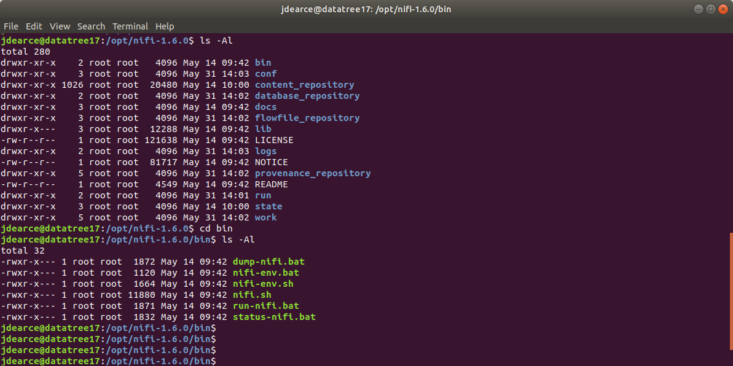
You are now in the ‘/opt/nifi-1.6.0/bin’ directory now let’s see if you have execute privilege on the nifi.sh shell script the ls shoes you this and if not we will use the chmod command as you see below.

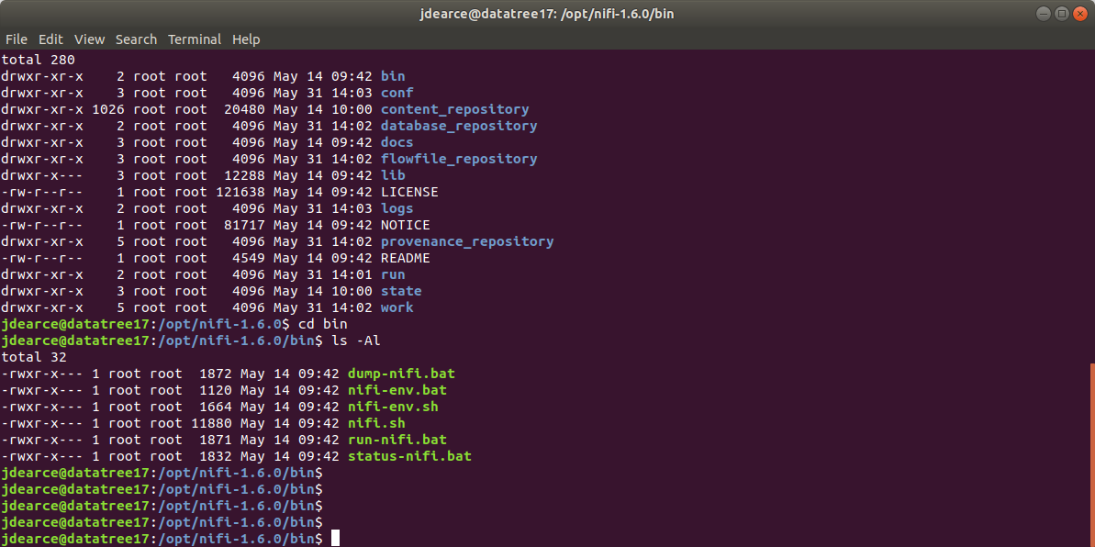

If not the command is chmod 750 nifi.sh and now you have execute on that script.

jdearce@datatree17:/opt/nifi-1.6.0/bin$ ls
dump-nifi.bat nifi-env.bat nifi-env.sh nifi.sh run-nifi.bat status-nifi.bat
jdearce@datatree17:/opt/nifi-1.6.0/bin$ sudo sh nifi.sh start
[sudo] password for jdearce:
nifi.sh: JAVA_HOME not set; results may vary

Java home:
NiFi home: /opt/nifi-1.6.0

Bootstrap Config File: /opt/nifi-1.6.0/conf/bootstrap.conf

jdearce@datatree17:/opt/nifi-1.6.0/bin$ sudo sh nifi.sh status
nifi.sh: JAVA_HOME not set; results may vary

Java home:
NiFi home: /opt/nifi-1.6.0

Bootstrap Config File: /opt/nifi-1.6.0/conf/bootstrap.conf

2018-05-31 14:01:24,677 INFO [main] org.apache.nifi.bootstrap.Command Apache NiFi is currently running, listening to Bootstrap on port 46583, PID=5116

jdearce@datatree17:/opt/nifi-1.6.0/bin$

Starting NiFi
Once NiFi has been downloaded and installed as described above, it can be started by using the mechanism appropriate for your operating system.

For Windows Users
On Windows install the Java JDK and create the Java JAVA_HOME environmental variable. For Windows users, navigate to the folder where NiFi was installed. Within this folder is a sub-folder named bin. Navigate to this sub-folder and double-click the run-nifi.bat file.#####
This will launch NiFi and leave it running in the foreground. To shut down NiFi, select the window that was launched and hold the Ctrl key while pressing C. On Window Nifi runs as a process and can’t run as service

For Linux/Mac OS X users
- For Linux and OS X users, use a Terminal window to navigate to the directory where NiFi was installed. Issue the ‘export JAVA_HOME=/home/jdearce/jdk1.8.0_171’ command. ####
- To run NiFi in the foreground, run sudo sh bin/nifi.sh run. This will leave the application running until the user presses Ctrl-C. At that time, it will initiate shutdown of the application.
- To run NiFi in the background, instead run sudo sh bin/nifi.sh start. This will initiate the application to begin running.
- To check the status and see if NiFi is currently running, execute the command bin/nifi.sh status. NiFi can be shutdown by executing the command sudo sh bin/nifi.sh stop.

Installing as a Service
Currently, installing NiFi as a service is supported only for Linux and Mac OS X users.
- To install the application as a service, navigate to the installation directory in a Terminal window and execute the command bin/nifi.sh install to install the service with the default name nifi.
- To specify a custom name for the service, execute the command with an optional second argument that is the name of the service.
- For example, to install NiFi as a service with the name dataflow, use the command bin/nifi.sh install dataflow.
- Once installed, the service can be started and stopped using the appropriate commands, such as sudo service nifi start and sudo service nifi stop.
- Additionally, the running status can be checked via sudo service nifi status.

I Started NiFi. Now What?
Now that NiFi has been started, we can bring up the User Interface (UI) in order to create and monitor our dataflow. To get started, open a web browser and navigate to http://localhost:8080/nifi. The port can be changed by editing the nifi.properties file in the NiFi conf directory, but the default port is 8080.

This will bring up the User Interface, which at this point is a blank canvas for orchestrating a dataflow:
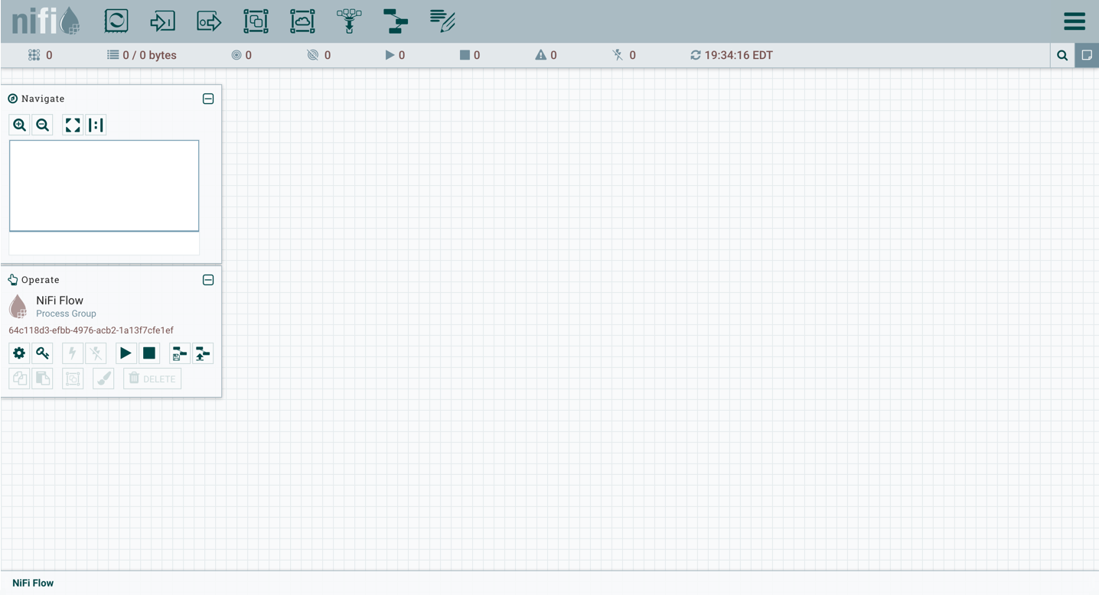
The UI has multiple tools to create and manage your first dataflow
Started NiFi on Ambari/Hadoop and Ubuntu different
On the Hortonworks sandbox VM it’s a little different here you have a complex system where the default port of Nifi is already in use. Now that NiFi has been started, we can bring up the User Interface (UI) in order to create and monitor our dataflow. After the install and startup go to the web page for nifi.

To get started, we opened a web browser and navigate to http://localhost:8080/nifi and then nothing happened the nifi web page would not come up but nifi was up and running.
We realized that something must be blocking it, so we had a port conflict and we checked.
For Ambari this is also the default port so we had to change Nifi’s to 9090 this change was done to the
‘properties.nifi’ file which is in the conf directory we changed the line ‘nifi.web.http.port=8080’ to this ‘nifi.web.http.port=9090’ and nifi came up with no problems after we restarted it.

The port can be changed by editing the nifi.properties file in the NiFi conf directory, but the default port is 8080.

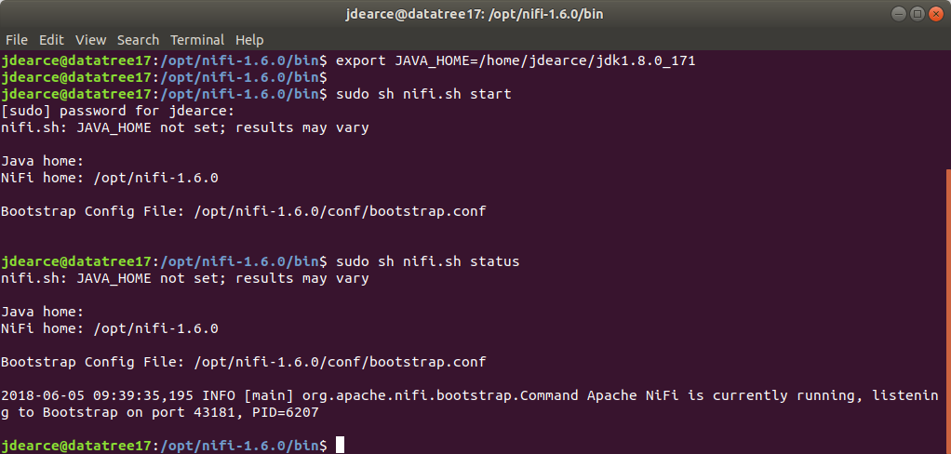

Useful web sites

https://nifi.apache.org/docs/nifi-docs/html/overview.html

https://www.google.com/search?source=hp&ei=te4EW92xDdLa5gLemIyYBg&q=what+is+apache+nifi&oq=what+is+apache+nifi&gs_l=psy-ab.3..0l2.3190.30794.0.32628.24.21.2.0.0.0.165.1607.20j1.21.0....0...1c.1.64.psy-ab..1.23.1617.0..35i39k1j0i131k1j0i131i20i264k1j0i20i264k1j0i13k1j0i8i13i30k1j0i7i30k1.0.WUslreld4yE

Properities.nifi
# Licensed to the Apache Software Foundation (ASF) under one or more
# contributor license agreements. See the NOTICE file distributed with
# this work for additional information regarding copyright ownership.
# The ASF licenses this file to You under the Apache License, Version 2.0
# (the "License"); you may not use this file except in compliance with
# the License. You may obtain a copy of the License at
#
# http://www.apache.org/licenses/LICENSE-2.0
#
# Unless required by applicable law or agreed to in writing, software
# distributed under the License is distributed on an "AS IS" BASIS,
# WITHOUT WARRANTIES OR CONDITIONS OF ANY KIND, either express or implied.
# See the License for the specific language governing permissions and
# limitations under the License.

# Core Properties #
nifi.flow.configuration.file=./conf/flow.xml.gz
nifi.flow.configuration.archive.enabled=true
nifi.flow.configuration.archive.dir=./conf/archive/
nifi.flow.configuration.archive.max.time=30 days
nifi.flow.configuration.archive.max.storage=500 MB
nifi.flow.configuration.archive.max.count=
nifi.flowcontroller.autoResumeState=true
nifi.flowcontroller.graceful.shutdown.period=10 sec
nifi.flowservice.writedelay.interval=500 ms
nifi.administrative.yield.duration=30 sec
# If a component has no work to do (is "bored"), how long should we wait before checking again for work?
nifi.bored.yield.duration=10 millis

nifi.authorizer.configuration.file=./conf/authorizers.xml
nifi.login.identity.provider.configuration.file=./conf/login-identity-providers.xml
nifi.templates.directory=./conf/templates
nifi.ui.banner.text=
nifi.ui.autorefresh.interval=30 sec
nifi.nar.library.directory=./lib
nifi.nar.working.directory=./work/nar/
nifi.documentation.working.directory=./work/docs/components

####################
# State Management #
####################
nifi.state.management.configuration.file=./conf/state-management.xml
# The ID of the local state provider
nifi.state.management.provider.local=local-provider
# The ID of the cluster-wide state provider. This will be ignored if NiFi is not clustered but must be populated if running in a cluster.
nifi.state.management.provider.cluster=zk-provider
# Specifies whether or not this instance of NiFi should run an embedded ZooKeeper server
nifi.state.management.embedded.zookeeper.start=false
# Properties file that provides the ZooKeeper properties to use if <nifi.state.management.embedded.zookeeper.start> is set to true
nifi.state.management.embedded.zookeeper.properties=./conf/zookeeper.properties

# H2 Settings
nifi.database.directory=./database_repository
nifi.h2.url.append=;LOCK_TIMEOUT=25000;WRITE_DELAY=0;AUTO_SERVER=FALSE

# FlowFile Repository
nifi.flowfile.repository.implementation=org.apache.nifi.controller.repository.WriteAheadFlowFileRepository
nifi.flowfile.repository.wal.implementation=org.apache.nifi.wali.SequentialAccessWriteAheadLog
nifi.flowfile.repository.directory=./flowfile_repository
nifi.flowfile.repository.partitions=256
nifi.flowfile.repository.checkpoint.interval=2 mins
nifi.flowfile.repository.always.sync=false

nifi.swap.manager.implementation=org.apache.nifi.controller.FileSystemSwapManager
nifi.queue.swap.threshold=20000
nifi.swap.in.period=5 sec
nifi.swap.in.threads=1
nifi.swap.out.period=5 sec
nifi.swap.out.threads=4

# Content Repository
nifi.content.repository.implementation=org.apache.nifi.controller.repository.FileSystemRepository
nifi.content.claim.max.appendable.size=1 MB
nifi.content.claim.max.flow.files=100
nifi.content.repository.directory.default=./content_repository
nifi.content.repository.archive.max.retention.period=12 hours
nifi.content.repository.archive.max.usage.percentage=50%
nifi.content.repository.archive.enabled=true
nifi.content.repository.always.sync=false
nifi.content.viewer.url=../nifi-content-viewer/

# Provenance Repository Properties
nifi.provenance.repository.implementation=org.apache.nifi.provenance.PersistentProvenanceRepository
nifi.provenance.repository.debug.frequency=1_000_000
nifi.provenance.repository.encryption.key.provider.implementation=
nifi.provenance.repository.encryption.key.provider.location=
nifi.provenance.repository.encryption.key.id=
nifi.provenance.repository.encryption.key=

# Persistent Provenance Repository Properties
nifi.provenance.repository.directory.default=./provenance_repository
nifi.provenance.repository.max.storage.time=24 hours
nifi.provenance.repository.max.storage.size=1 GB
nifi.provenance.repository.rollover.time=30 secs
nifi.provenance.repository.rollover.size=100 MB
nifi.provenance.repository.query.threads=2
nifi.provenance.repository.index.threads=2
nifi.provenance.repository.compress.on.rollover=true
nifi.provenance.repository.always.sync=false
nifi.provenance.repository.journal.count=16
# Comma-separated list of fields. Fields that are not indexed will not be searchable. Valid fields are:
# EventType, FlowFileUUID, Filename, TransitURI, ProcessorID, AlternateIdentifierURI, Relationship, Details
nifi.provenance.repository.indexed.fields=EventType, FlowFileUUID, Filename, ProcessorID, Relationship
# FlowFile Attributes that should be indexed and made searchable. Some examples to consider are filename, uuid, mime.type
nifi.provenance.repository.indexed.attributes=
# Large values for the shard size will result in more Java heap usage when searching the Provenance Repository
# but should provide better performance
nifi.provenance.repository.index.shard.size=500 MB
# Indicates the maximum length that a FlowFile attribute can be when retrieving a Provenance Event from
# the repository. If the length of any attribute exceeds this value, it will be truncated when the event is retrieved.
nifi.provenance.repository.max.attribute.length=65536
nifi.provenance.repository.concurrent.merge.threads=2
nifi.provenance.repository.warm.cache.frequency=1 hour

# Volatile Provenance Respository Properties
nifi.provenance.repository.buffer.size=100000

# Component Status Repository
nifi.components.status.repository.implementation=org.apache.nifi.controller.status.history.VolatileComponentStatusRepository
nifi.components.status.repository.buffer.size=1440
nifi.components.status.snapshot.frequency=1 min

# Site to Site properties
nifi.remote.input.host=
nifi.remote.input.secure=false
nifi.remote.input.socket.port=
nifi.remote.input.http.enabled=true
nifi.remote.input.http.transaction.ttl=30 sec
nifi.remote.contents.cache.expiration=30 secs

# web properties #
nifi.web.war.directory=./lib
nifi.web.http.host=
nifi.web.http.port=8080
nifi.web.http.network.interface.default=
nifi.web.https.host=
nifi.web.https.port=
nifi.web.https.network.interface.default=
nifi.web.jetty.working.directory=./work/jetty
nifi.web.jetty.threads=200
nifi.web.max.header.size=16 KB
nifi.web.proxy.context.path=
nifi.web.proxy.host=

# security properties #
nifi.sensitive.props.key=
nifi.sensitive.props.key.protected=
nifi.sensitive.props.algorithm=PBEWITHMD5AND256BITAES-CBC-OPENSSL
nifi.sensitive.props.provider=BC
nifi.sensitive.props.additional.keys=

nifi.security.keystore=
nifi.security.keystoreType=
nifi.security.keystorePasswd=
nifi.security.keyPasswd=
nifi.security.truststore=
nifi.security.truststoreType=
nifi.security.truststorePasswd=
nifi.security.needClientAuth=
nifi.security.user.authorizer=managed-authorizer
nifi.security.user.login.identity.provider=
nifi.security.ocsp.responder.url=
nifi.security.ocsp.responder.certificate=

# OpenId Connect SSO Properties #
nifi.security.user.oidc.discovery.url=
nifi.security.user.oidc.connect.timeout=5 secs
nifi.security.user.oidc.read.timeout=5 secs
nifi.security.user.oidc.client.id=
nifi.security.user.oidc.client.secret=
nifi.security.user.oidc.preferred.jwsalgorithm=

# Apache Knox SSO Properties #
nifi.security.user.knox.url=
nifi.security.user.knox.publicKey=
nifi.security.user.knox.cookieName=hadoop-jwt
nifi.security.user.knox.audiences=

# Identity Mapping Properties #
# These properties allow normalizing user identities such that identities coming from different identity providers
# (certificates, LDAP, Kerberos) can be treated the same internally in NiFi. The following example demonstrates normalizing
# DNs from certificates and principals from Kerberos into a common identity string:
#
# nifi.security.identity.mapping.pattern.dn=^CN=(.*?), OU=(.*?), O=(.*?), L=(.*?), ST=(.*?), C=(.*?)$
# nifi.security.identity.mapping.value.dn=$1@$2
# nifi.security.identity.mapping.pattern.kerb=^(.*?)/instance@(.*?)$
# nifi.security.identity.mapping.value.kerb=$1@$2

# cluster common properties (all nodes must have same values) #
nifi.cluster.protocol.heartbeat.interval=5 sec
nifi.cluster.protocol.is.secure=false

# cluster node properties (only configure for cluster nodes) #
nifi.cluster.is.node=false
nifi.cluster.node.address=
nifi.cluster.node.protocol.port=
nifi.cluster.node.protocol.threads=10
nifi.cluster.node.protocol.max.threads=50
nifi.cluster.node.event.history.size=25
nifi.cluster.node.connection.timeout=5 sec
nifi.cluster.node.read.timeout=5 sec
nifi.cluster.node.max.concurrent.requests=100
nifi.cluster.firewall.file=
nifi.cluster.flow.election.max.wait.time=5 mins
nifi.cluster.flow.election.max.candidates=

# zookeeper properties, used for cluster management #
nifi.zookeeper.connect.string=
nifi.zookeeper.connect.timeout=3 secs
nifi.zookeeper.session.timeout=3 secs
nifi.zookeeper.root.node=/nifi

# Zookeeper properties for the authentication scheme used when creating acls on znodes used for cluster management
# Values supported for nifi.zookeeper.auth.type are "default", which will apply world/anyone rights on znodes
# and "sasl" which will give rights to the sasl/kerberos identity used to authenticate the nifi node
# The identity is determined using the value in nifi.kerberos.service.principal and the removeHostFromPrincipal
# and removeRealmFromPrincipal values (which should align with the kerberos.removeHostFromPrincipal and kerberos.removeRealmFromPrincipal
# values configured on the zookeeper server).
nifi.zookeeper.auth.type=
nifi.zookeeper.kerberos.removeHostFromPrincipal=
nifi.zookeeper.kerberos.removeRealmFromPrincipal=

# kerberos #
nifi.kerberos.krb5.file=

# kerberos service principal #
nifi.kerberos.service.principal=
nifi.kerberos.service.keytab.location=

# kerberos spnego principal #
nifi.kerberos.spnego.principal=
nifi.kerberos.spnego.keytab.location=
nifi.kerberos.spnego.authentication.expiration=12 hours

# external properties files for variable registry
# supports a comma delimited list of file locations
nifi.variable.registry.properties=

Bootstrap.conf

#
# Licensed to the Apache Software Foundation (ASF) under one or more
# contributor license agreements. See the NOTICE file distributed with
# this work for additional information regarding copyright ownership.
# The ASF licenses this file to You under the Apache License, Version 2.0
# (the "License"); you may not use this file except in compliance with
# the License. You may obtain a copy of the License at
#
# http://www.apache.org/licenses/LICENSE-2.0
#
# Unless required by applicable law or agreed to in writing, software
# distributed under the License is distributed on an "AS IS" BASIS,
# WITHOUT WARRANTIES OR CONDITIONS OF ANY KIND, either express or implied.
# See the License for the specific language governing permissions and
# limitations under the License.
#

# Java command to use when running NiFi
java=java

# Username to use when running NiFi. This value will be ignored on Windows.
run.as=

# Configure where NiFi's lib and conf directories live
lib.dir=./lib
conf.dir=./conf

# How long to wait after telling NiFi to shutdown before explicitly killing the Process
graceful.shutdown.seconds=20

# Disable JSR 199 so that we can use JSP's without running a JDK
java.arg.1=-Dorg.apache.jasper.compiler.disablejsr199=true

# JVM memory settings
java.arg.2=-Xms512m
java.arg.3=-Xmx512m

# Enable Remote Debugging
#java.arg.debug=-agentlib:jdwp=transport=dt_socket,server=y,suspend=n,address=8000

java.arg.4=-Djava.net.preferIPv4Stack=true

# allowRestrictedHeaders is required for Cluster/Node communications to work properly
java.arg.5=-Dsun.net.http.allowRestrictedHeaders=true
java.arg.6=-Djava.protocol.handler.pkgs=sun.net.www.protocol

# The G1GC is still considered experimental but has proven to be very advantageous in providing great
# performance without significant "stop-the-world" delays.
java.arg.13=-XX:+UseG1GC

#Set headless mode by default
java.arg.14=-Djava.awt.headless=true

# Master key in hexadecimal format for encrypted sensitive configuration values
nifi.bootstrap.sensitive.key=

# Sets the provider of SecureRandom to /dev/urandom to prevent blocking on VMs
java.arg.15=-Djava.security.egd=file:/dev/urandom

# Requires JAAS to use only the provided JAAS configuration to authenticate a Subject, without using any "fallback" methods (such as prompting for username/password)
# Please see https://docs.oracle.com/javase/8/docs/technotes/guides/security/jgss/single-signon.html, section "EXCEPTIONS TO THE MODEL"
java.arg.16=-Djavax.security.auth.useSubjectCredsOnly=true

###
# Notification Services for notifying interested parties when NiFi is stopped, started, dies
###

# XML File that contains the definitions of the notification services
notification.services.file=./conf/bootstrap-notification-services.xml

# In the case that we are unable to send a notification for an event, how many times should we retry?
notification.max.attempts=5

# Comma-separated list of identifiers that are present in the notification.services.file; which services should be used to notify when NiFi is started?
#nifi.start.notification.services=email-notification

# Comma-separated list of identifiers that are present in the notification.services.file; which services should be used to notify when NiFi is stopped?
#nifi.stop.notification.services=email-notification

# Comma-separated list of identifiers that are present in the notification.services.file; which services should be used to notify when NiFi dies?
#nifi.dead.notification.services=email-notification

– ##################################################################

OS Nifi logs

– Start up Nifi
jdearce@datatree17:~$ cd /opt
jdearce@datatree17:/opt$ ls
google nifi-1.6.0
jdearce@datatree17:/opt$ cd nifi-1.6.0
jdearce@datatree17:/opt/nifi-1.6.0$ cd bin
jdearce@datatree17:/opt/nifi-1.6.0/bin$ ls
dump-nifi.bat nifi-env.sh run-nifi.bat
nifi-env.bat nifi.sh status-nifi.bat
jdearce@datatree17:/opt/nifi-1.6.0/bin$ sudo shnifi.sh start
[sudo] password for jdearce:
sudo: shnifi.sh: command not found
jdearce@datatree17:/opt/nifi-1.6.0/bin$ sudo sh nifi.sh start
nifi.sh: JAVA_HOME not set; results may vary

Java home:
NiFi home: /opt/nifi-1.6.0

Bootstrap Config File: /opt/nifi-1.6.0/conf/bootstrap.conf

jdearce@datatree17:/opt/nifi-1.6.0/bin$ sudo sh nifi.sh status
nifi.sh: JAVA_HOME not set; results may vary

Java home:
NiFi home: /opt/nifi-1.6.0

Bootstrap Config File: /opt/nifi-1.6.0/conf/bootstrap.conf

2018-05-22 22:59:29,987 INFO [main] org.apache.nifi.bootstrap.Command Apache NiFi is currently running, listening to Bootstrap on port 38037, PID=636

jdearce@datatree17:/opt/nifi-1.6.0/bin$
jdearce@datatree17:/opt/nifi-1.6.0/bin$
jdearce@datatree17:/opt/nifi-1.6.0/bin$ export JAVA_HOME=/home/jdearce/jdk1.8.0_171
jdearce@datatree17:/opt/nifi-1.6.0/bin$ sudo sh nifi.sh status[sudo] password for jdearce:
nifi.sh: JAVA_HOME not set; results may vary

Java home:
NiFi home: /opt/nifi-1.6.0

Bootstrap Config File: /opt/nifi-1.6.0/conf/bootstrap.conf

2018-05-22 23:31:40,242 INFO [main] org.apache.nifi.bootstrap.Command Apache NiFi is currently running, listening to Bootstrap on port 38037, PID=636

jdearce@datatree17:/opt/nifi-1.6.0/bin$

